31 October 2025

NOTICE OF BASEBALL QUEENSLAND 2024/25 ANNUAL GENERAL MEETING

The Annual General Meeting of Baseball Queensland will be held on Wednesday 3 December 2025 from 6:30pm at Sports House, 150 Caxton St, Milton QLD. Zoom Session details will be circulated to Delegates directly to facilitate virtual attendance options.

MEETING AGENDA
a) record of attendance and confirmation of Proxies;
b) confirmation of minutes from the previous AGM;
c) the Board of Management and Chief Executive Officer's reports for the preceding financial year;
d) the financial report of Baseball Queensland for the preceding financial year;
e) the auditor's report upon the books and accounts for the preceding financial year;
f) the appointment of an auditor for the following year;
g) the election of two members of the Board of Management;
h) any vote required to resolve Life Membership nomination;
i) general business as required.

CALL FOR NOMINATIONS
Baseball Queensland hereby calls for nominations for Candidates for election to the Board of Directors for Baseball Queensland. Nominations are to be submitted to the Chief Executive Officer gareth@baseballqld.asn.au by no later than COB 12 November 2025. Please note that nominations need to be submitted on Form A – Page 18 of the BQ Constitution. Candidates are also asked to review the information available from the link below and complete the Skills Matrix and Profile available from this link: https://www.baseballqueensland.com.au/information-and-forms-for-bq-director-candidates/ Please submit the Skills Matrix/Profile with each nomination as this will assist the Members to understand the skills and experience each Candidate has to offer.

Life Membership nominations can be submitted at this link>>> by no later than 20 November 2025.

Meeting notice issued by order of the Board of Management – Baseball Queensland.

Kind regards,

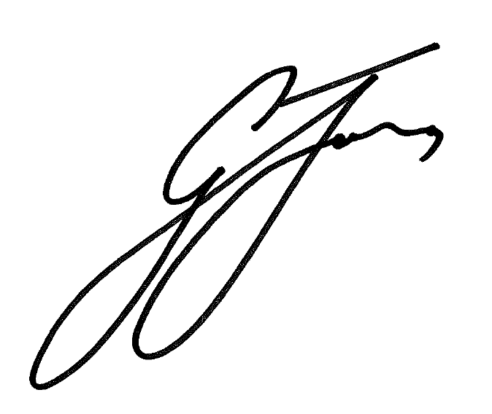
Gareth Jones
Chief Executive Officer
Baseball Queensland

